ST. DOMINIC CATHOLIC CHURCH
LOS ANGELES
Nuptial Mass
Bride & Groom
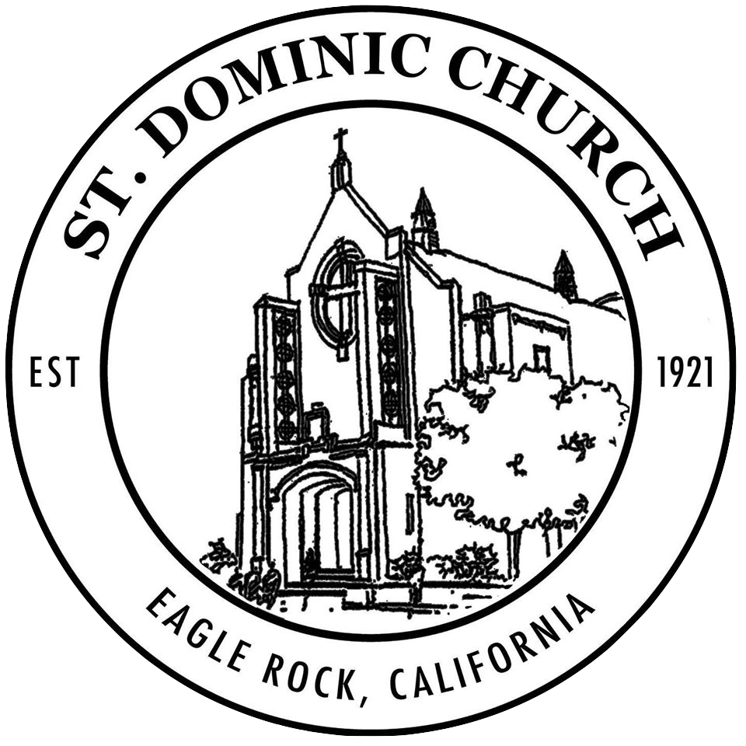

Father xx yy, O.P., Celebrant

Day
Date & year
time
Wedding Party

Parents of the Bride
X & Y
Parents of the Groom
X & Y
Groomsmen
X & Y
X & Y
X & Y
X & Y
X & Y
X & Y

Bridesmaids
X & Y
X & Y
X & Y
X & Y
X & Y
X & Y

Please turn off all camera flashes, floodlights and cell phone ringtones during the Nuptial Mass
Please join in all parts in Bold Type
Music for the seating of honored family members
Your music choice Composer
Music for the bridal party
Your music choice Composer
(Stand)
Music for the bride’s procession
Your music choice Composer
Introductory Rites
Sign of the Cross
All make the Sign of the Cross as the Priest says:
In the name of the Father, and of the Son,
✠ and of the Holy Spirit. Amen.
Greeting
The priest greets the people in these or similar words:
The grace of our Lord Jesus Christ,
and the love of God,
and the communion of the Holy Spirit
be with you all.
And with your spirit.
The Gloria is sung
The Collect
Then the Priest says the Collect prayer, at the end of which the people acclaim: Amen
The Liturgy Of The Word
(Sit)
First Reading Your choice of reading
Read by Xxxx Yyyy
The word of the Lord.
Thanks be to God.
After a period of silence, the responsorial psalm is sung.
Psalm (sung, normally – put the text below)
Psalm text
Second Reading Your choice of reading
Read by Xxxx Yyyy
The word of the Lord.
Thanks be to God.
A time of silence follows the reading.
(Stand)
Gospel Acclamation

Gospel Reading Your choice of reading
The Lord be with you.
And with your spirit.
A reading from the Holy Gospel according to N.
✠ Glory to you, O Lord.
At the end of the Gospel, the Deacon, or the Priest acclaims
The Gospel of the Lord.
Praise to you, Lord Jesus Christ.
(Sit)
Homily
The Rite of Marriage
Instruction
Exchange of Vows
Blessing and Exchange of Rings
Arras (coins) / Veil / Lazo (optional)
Prayer of the Faithful
(Stand)
Led by reader’s name
For (intention) Let us pray to the Lord,
Lord, hear our prayer.

Liturgy of the Eucharist
(Sit)
Preparation of the Altar and the Gifts
The gifts are presented by xx & yy
Music for the Preparation
Title Composer
Bread and wine are brought to the table and the priest prepares these gifts.
(Stand)
The priest then invites all to pray.
May the Lord accept the sacrifice at your hands
for the praise and glory of his name,
for our good, and the good of all his holy Church.
The Lord be with you.
And with your spirit.
Lift up your hearts.
We lift them up to the Lord.
Let us give thanks to the Lord, our God.
It is right and just.
The priest continues with the preface proper to the celebration of the day.
Sanctus
(Kneel)
The priest continues with the words of institution.
Memorial Acclamation
The priest concludes the Eucharistic prayer with this doxology:
Through him, and with him, and in him, O God, almighty Father, in the unity of the Holy Spirit, all glory and honor is yours, forever and ever.
Amen!
Communion Rite
(Stand)
The Lord’s Prayer
Our Father, who art in heaven,
hallowed be thy name;
thy kingdom come;
thy will be done on earth as it is in heaven.
Give us this day our daily bread;
and forgive us our trespasses
as we forgive those who trespass against us;
and lead us not into temptation,
but deliver us from evil.
Nuptial Blessing
Sign of Peace
The peace of the Lord be with you always.
And with your spirit.
All exchange a sign of peace.
Lamb of God
The priest then invites all to share in Holy Communion.
Behold the Lamb of God, behold him who takes away the sins of the world. Blessed are those called to the supper of the Lamb.
Lord, I am not worthy that you should enter under my roof, but only say the word and my soul shall be healed.
The body (blood) of Christ. Amen.
Those in communion with the Catholic Church are invited to receive communion. We welcome those not prepared for communion to come forward to make a spiritual communion. If you wish to make a spiritual communion, please cross your arms over your chest as you approach the Eucharistic Minister.
Music during Communion
Title Composer
After communion, a time of silence is observed.
Concluding Rite
(Stand)
Final Blessing
Dismissal
Presentation of the Couple
Recessional Music
Title Composer

ST. DOMINIC CATHOLIC CHURCH

2002 Merton Avenue, Los Angeles, CA
(323) 254-2519 - www.saintdominics.org
Fr. Peter Rogers, OP, Pastor; Fr. Francis Goode, OP, Associate Pastor; Fr. Isaiah Mary Molano, OP, Prior
Rudy Acosta, Director of Music,
xxx, Cantor

